**CHILD VACCINATION MANAGEMENT SYSTEM**

*Developed By*

|  |
| --- |
| **Zainab Mahmood**  **311-FBS/BSIT4/F18**  **Um-e-Mehmoona**  **305-FBS/BSIT4/F18** |
|  |

BS Information Technology

*Supervisor*

**Ms. Asma Sajjad**

**Ms. Talat Ambreen**

Department of Computer Science & Software Engineering Faculty of Basic and Applied Sciences

International Islamic University, Islamabad

(2022)

**International Islamic University Islamabad (2022)**

**IN THE NAME OF ALLAH, THE BENEFICENT THE MERCIFUL**

Department of Computer Science and Software Engineering

International Islamic University, Islamabad.

**Final Approval**

Dated:

It is certified that we have read the project report submitted by Um-e-Mehmoona, 305/FBAS/BSIT/F18 and Zainab Mahmood, 311/FBAS/BSIT/F18 it is our judgment that this project is of sufficient standard to warrant its acceptance by the International Islamic University, Islamabad for the BS Degree in Information Technology.

**Committee:**

**External Examiner**

[External Examiner Name]

[Designation] [Signature, Date]

[Department, Organization]

**Internal Examiner**

[Internal Examiner Name]

[Designation] [Signature, Date]

[Department]

**Supervisor**

Ms. Asma Sajjad

Lecturer [Signature, Date]

Ms. Talat Ambreen

Lecturer

**Dissertation**

A dissertation submitted to the Department of Computer Science & Software Engineering, International Islamic University, Islamabad, as a partial fulfillment of the requirements for the award of the degree of Bachelors in Information Technology.

**Dedication**

I dedicate this project to my beloved parents, respected teachers and all those who prayed for our success.

**Declaration**

I hereby declare that this Software, neither as a whole nor as a part thereof has been copied out from any source. It is further declared that I have developed this Software entirely on the basis of my personal efforts made under the sincere guidance of my teachers and supervisor.

No portion of the work presented in this report has been submitted in support of any application for any other degree or qualification of this or any other university or institute of learning.

**Zainab Mahmood**

311/FBAS/BSIT/F18

**Um-e-Mehmoona**

305/FBAS/BSIT/F18

**Acknowledgement**

All praise to Almighty Allah, who gave me the understanding, courage and patience to complete this project.

Thanks to my parents and all well-wishers, who helped me during my most difficult times and it is due to their untiring efforts that I am at this position today.

I express my gratitude to my kind Teacher **Ms. Asma Sajjad** and **Ms. Talat Ambreen** for providing me the opportunity to learn and enhance my knowledge. She had been ready to help and guide me throughout the project.

**Project in Brief**

|  |  |
| --- | --- |
| **Project Title:** | CHILD VACCINATION MANAGEMENT SYSTEM |
| **Objective:** | The aim of the project is to provide fast and secure record keeping application, and our system will keep track of all BHU (Basic Health Unit) activities regarding child. |
| **Undertaken By:** | Zainab Mahmood  Um-e-Mehmoona |
| **Supervised By:** | Ms. Asma Sajjad  Lecturer  Ms. Talat Ambreen  Lecturer |
| **Date Started:** | February, 2022 |
| **Date Completed:** | August, 2022 |
| **Tools Used:** | Tools are used in the project:  Xampp Server  Visual Studio Code  Visual Paradigm |
| **System Used:** | Intel(R) Core(TM) i5-6300U CPU @ 2.40GHz, 2496 Mhz 8 GB RAM, 64-bit Window OS |

**Abstract**

The “Online Child Vaccination System” is a platform for those who need to vaccinate their children’s timely and need to keep track of vaccination history. The website can let the users to use system for managing basic health related tasks efficiently. A database will keep track of all the children’s vaccination record.

CHAPTER 1 INTRODUCTION 12

1. Introduction: 2

1.1 Introduction of the Project: 2

1.2 Purpose: 2

1.3 Project Motivation: 3

1.4 Scope: 3

2 Problem Analysis: 5

2.1 Existing System 5

2.2 Drawbacks of Existing System 5

2.3 Proposed System 5

2.4 Stakeholders 6

2.5 Actor Goal List: 6

3 System Analysis: 9

3.1 Problem overview: 9

3.2 Functional Requirement: 9

3.2.1 Parent Requirement: 9

3.2.1.1 View Vaccination detail: 9

3.2.1.2 Sign-in/Sign up: 9

3.2.1.3 Manage Account: 9

3.2.1.4 Get relevant vaccine information: 9

3.2.1.5 Search: 9

3.2.1.6 Vaccination Alert: 10

3.2.1.7 Report of Vaccination Taken: 10

3.2.1.8 Immunization Dashboard: 10

3.2.1.9 Contact Vaccination center: 10

3.2.1.10 Report a Problem: 10

3.2.1.11 Website Feedback: 10

3.2.1.12 Appointment Reschedule Alert: 10

3.2.2 Admin Requirements: 10

3.2.2.1 Sign-in: 10

3.2.2.2 Manage Website: 10

3.2.2.3 Manage Child Data: 10

3.2.2.4 View Vaccination status: 10

3.2.2.5 View Feedback: 10

3.2.3 Coordinator Requirements: 11

3.2.3.1 Sign-in: 11

3.2.3.2 Authentication: 11

3.2.3.3 Access Dashboard: 11

3.2.3.4 Insert Data: 11

3.2.3.5 Update Data: 11

3.2.3.6 Create Report: 11

3.2.3.7 View Report: 11

3.2.4 Medical Officer Requirements: 11

3.2.4.1 Sign-in: 11

3.2.4.2 Authentication: 11

3.2.4.3 Access Dashboard: 11

3.2.4.4 Read Data: 11

3.2.4.5 Insert Data: 12

3.2.4.6 Update Data: 12

3.2.4.7 Delete Data: 12

3.2.4.8 Manage Database: 12

3.3 Non-Functional Requirement: 12

3.3.1 Performance: 12

3.3.2 User friendly: 12

3.3.3 Reliability: 12

3.3.4 Availability: 12

3.3.5 Security: 13

3.3.6 Maintainability 13

3.4 Use case diagram: 13

3.5 Fully Dressed Use Cases 15

4 System Design 28

4.1 Class Diagram 28

4.2 Interaction Diagram (Sequence): 29

4.2.1 Sequence Diagram of Login: 29

4.2.2 Sequence Diagram of Register: 30

4.2.3 Sequence Diagram of View and manage feedback: 31

4.2.4 Sequence Diagram of View Report: 32

4.2.5 Sequence Diagram of Access Dashboard: 32

4.3 Entity Relation Diagram: 33

4.4 Activity Diagram: 34

# CHAPTER 1 INTRODUCTION

# Introduction:

This chapter includes the introduction of the requirements and scope of the system. This chapter is dealing with the needs and purpose of writing this documentation from the perspective of the developer. This section also elaborates the scope of the system and its impacts on the community, additionally chapter one gives a preview about this project and how explain the purpose and motivation of this project.

## Introduction of the Project:

Immunization is a key component of primary health care and an indisputable human right. It’s also one of the best health investments for children’s. Vaccines are also critical to the prevention and control of infectious-disease outbreaks.

In this project of online child vaccination management system it will cover the whole details about a child from time to born to 15 months. The system will tell each and every thing about the history of the children means from the time born we will give the type of vaccinations till six months.

In the existing system, Vaccines are provided for infants and children under teenage by various aspects such as by attending school manually and there is a chance that some of the children’s and infants may miss the opportunity of getting vaccinated due to some mandatory reasons. Which leads to loss of life or gets affected by various diseases such as polio. This is a time delay process to wait for each and every one all over the places.

We can change this manual system into Online Child Vaccination Management System by collecting the info of infants, registered under website so that those who didn’t took vaccination can avail one more opportunity to save the life of their children. By this system a lot of man-hours can be saved and it is efficient too. Our system will provide fast and secure record keeping application, efficient management of child vaccination, and reduce chances of error and mistakes.

## Purpose:

The core purpose of this system is to provide an application which will be easy to use and will keep track of all BHU activities regarding child. It will reduce the occurrence of errors which does occur in paper based child vaccination management. Another important purpose of our system is to act as a report generator for child’s vaccination details like it will inform the admin about the child given vaccine doses from period of time, however parents can also use this system for searching their child vaccine record and get informed through message service.

This system will provide support to medical officers of fixed and outreach centers to improve full vaccination coverage, we will have a significant increase in vaccination coverage using the system. Medical officers will improve their working efficiency of managing childhood vaccination.

## Project Motivation:

As the world looks at health systems for vaccinations, public and private health systems worldwide are being presented with a growing number of new challenges such as Data transparency was the largest hurdle and issues of not unavailability of updated data.Vaccine scheduling is another major issue which motivated us to create this online child vaccination system. Another issue is the paper record that will be distributed to every citizen related to their children’s vaccination so by creating online system parents will have a digital record behind it in case they lose it.

Our Motivation is to overcome all these issues by keeping web portals and registration in sync. This system will also manage child’s vaccine information, it will do report generation and our system will manage the record of vaccination both of fixed and outreach centers. Vaccination scheduling and rescheduling is also be done in an automated way to help parents.

## Scope:

The target audience of our proposed system is Parents, Medical officers, Admin and Coordinator of the Medical center. As the system is a web based system so it can be accessed from all over the country but it is specifically made to cover a Tehsil area so this makes its scope. This system is made for a real client. Basic Health Unit (BHU) Office Taxila will officially own this website.

This system will help a user (parent) to perform various actions such as retrieving information about child vaccination (reports) and scheduling vaccinations. Further there will options where user or parent can register for child's vaccination. The website will have an admin who will have access to all the information present on the website. He will add, edit, and delete all information concerning a child. He can also add additional information related to a child. Our system will have a Medical Officer who will manage the database of our system. Then a Coordinator can perform authentication and will create reports.

Our system will not be accommodating the booking schedule of parents it is only for infants. Another thing which we are not including in our project is that our system will not cover the medical centers of whole country but it is only for Taxila (Tehsil level).

**CHAPTER 2**

**PROBLEM ANALYSIS**

# Problem Analysis:

This chapter will address the existing way of handling the current system, the difficulties face by the farm in the management of their operations and flaws that are associated with the existing system. This section also discusses the proposed system and elaborates how the proposed system is effective for solving the problems faced by the existing system.

## Existing System

With only two-thirds of children receiving full immunization, Pakistan is among those countries where immunization rates have been chronically low and those of on-time vaccination are even much lower. As in the existing scenario, some issues are poor programme structure and management, poor governance and capacity, issues in vaccine logistics, human resource deficiencies and old information systems. Which leads to loss of life precious lives. So manual system is not providing efficient solution for storing and managing data, they didn’t provide secure and fast solution.

## Drawbacks of Existing System

Using this existing system, some parents remain concerned about the use and [schedule](https://www.msdmanuals.com/home/children-s-health-issues/vaccination-of-children/childhood-vaccination-schedule) of vaccines in children. These concerns can lead some parents to vaccine hesitancy so parents delay or do not allow their children to be given some or all of the recommended vaccines despite the availability of vaccine services. Diseases that can be prevented by vaccines are much more likely to develop in children whose parents have refused one or more vaccines so this is a significant issue while using manual system.

According to the recommended schedule, children should be given several doses of vaccines against 10 or more different infections by age 6 years. But some parents have been concerned about the number of injections and doctor visits, so sometimes parents who are worried ask for a different vaccine schedule or ask to delay or exclude certain vaccines. However, the recommended schedule is designed to give the various vaccines at the ages when children begin to need protection against the diseases so this is another common drawback of manual vaccination system.

Another drawback is transforming record of Daily register to Permanent register takes a lot of time in currently ongoing manual card system of child vaccination management.

Important factors that are connected to vaccine coverage in Pakistan include female literacy, household income, supply of vaccines, and number of vaccinators and monitoring of this health initiative. These variables need to be improved.

## Proposed System

To remove all the disadvantages of existing system our proposed system provides a web based application. Our online system will provide an application which will be easy to use and will keep track of all BHU activities regarding child. It will be used as a report generator for child’s vaccination, and schedule booking is easily performed by the parent or user. Online registration can be easily done using this online system. Our system will provide vaccination information and recommend dosage for children’s of different age groups. So this proposed system will provide complete immunization monitoring.

## Stakeholders

Stakeholder are individuals, groups, or organization directly involved in a system or project.

Following are the stakeholders of our system:

* **Project Team:** In project team we have a developer who is responsible for developing the application and a designer for the design the system the user interface. We also have a tester to test the application.
* **Medical official:** A person who take an active role in overseeing the medical care of patients and the functions performed by medical staff.
* **Admin:** An administrator is the admin for the system that will manage the whole system.
* **Parent:** Parents make decisions about vaccination for their children, they communicate with the medical officers about best vaccinations available and also book schedules.
* **Coordinator:** A Coordinator is responsible for managing data of the system and ensuring that the system is free of unauthorized access.

## Actor Goal List:

Actor goal list include those actors who will use the system and it provide their goal list that they will perform in the application. My main actors of proposed system are Parent, Medical Officer, Coordinator and Admin.

|  |  |
| --- | --- |
| **Actors** | **Goal List** |
| Parent | Open the application  Sign up to application  View home page  View Vaccination detail  Manage Account  Get relevant vaccine information  Book Schedule  Get Vaccination Alerts  Print Report of Vaccination  View Immunization Dashboard  Contact Vaccination center  Report a Problem  Appointment Reschedule Alert  Provide Feedback |
| Medical Officer | Sign up  Authentication  Access dashboard  Read data  Insert data  Update data  Delete data  Manage Database |
| Coordinator | Sign up  Authentication  Access dashboard  Insert data  Update data  Create report  Update report |
| Admin | Sign up  Manage website  Manage children’s data  View vaccinations status  View feedback |

**Table 2.5.1 Table for Actor Goal List**

**CHAPTER 3**

**System Analysis**

# System Analysis:

Systems analysis is a problem-solving method that involves looking at the wider system, breaking apart the parts, and figuring out how it works in order to achieve a particular goal. This chapter describes the analysis model of the system. It explains problems, functional and non-functional requirements and uses cases of the system.

## Problem overview:

Currently, using the manual system parents have to visit the medical center to book vaccination schedules each time so some parents have been concerned about the number of doctor visits, so sometimes parents who are worried ask for a different vaccine schedule or ask to delay or exclude certain vaccines. This is the biggest concern of manual system. Our “Online Child Vaccination System” will provide an easy way for parent to register and book schedule by sitting at home.

## Functional Requirement:

Functional requirements are the description of the services that the system must offer. It describes a system or its component. A function is nothing but inputs to the system, its behavior, and outputs. Following are the functional requirements of the proposed system:

### Parent Requirement:

Following requirement are for the parent functionality:

#### View Vaccination detail:

The user can view the details of vaccination (vaccination date, vaccination status, child details, etc.)

#### Sign-in/Sign up:

To register for a vaccination on the website the user must sign up on our website and then sign in in order to make registration.

#### Manage Account:

After sign in parents can manage their account e.g. view previous and schedule vaccinations, edit their personal information like address, phone number, change password etc.

#### Get relevant vaccine information:

Parent can know the relevant vaccine information once they entered the child information.

#### Search:

The parent can search for their child’s vaccination detail by child name or child ID.

#### Vaccination Alert:

Parents can get notified through sms on their mobile phone about scheduled vaccination.

#### Report of Vaccination Taken:

Parents can get the report status of previous vaccination of their respective Infants

#### Immunization Dashboard:

Parent can access immunization dashboard to check diseases description and their rates in last 5 years.

#### Contact Vaccination center:

The parents can contact the vaccination center to acquire additional information.

#### Report a Problem:

The parents can report a problem about their child’s vaccination detail like the name of vaccination, date, or overall system performance. They can also report if they are unable to receive alerts on their mobile phones or email address.

#### Website Feedback:

The parent can provide us with their valuable feedback.

#### Appointment Reschedule Alert:

The parent will receive a sms on their mobile phone with rescheduled date for vaccination if the selected vaccination date is not available.

### Admin Requirements:

Following requirement are for the admin:

#### Sign-in:

Admin Sign In on the application if the login details are entered correctly.

#### Manage Website:

The admin will be able to manage the website like he can update contact information and upload new stuff which would be useful for other users.

#### Manage Child Data:

The Admin will be able to manage the child data like they can insert, update and delete data.

#### View Vaccination status:

Admin can view status of vaccination either completed or scheduled.

#### View Feedback:

The Admin can also view the feedback given by the parent.

### Coordinator Requirements:

Following requirement are for the coordinator:

#### Sign-in:

The System Coordinator shall be able to Sign In on the application if the login details are entered correctly.

#### Authentication:

The System Coordinator must have valid credentials to login so that the system shall login the SC.

#### Access Dashboard:

The System Coordinator shall be able to Access the dashboard if the login process is successfully completed.

#### Insert Data:

The System Coordinator shall also be able to insert data in the application if the new child come.

#### Update Data:

The System Coordinator shall be able to update data in the application if SC wants.

#### Create Report:

The System Coordinator should be able to create a report which system coordinator can access and view it

#### View Report:

The System Coordinator shall be able view all reports of vaccination from different perspective like date wise, Month wise or on specific date.

### Medical Officer Requirements:

Following requirement are for the medical officer:

#### Sign-in:

The Medical Officer shall sign in on the application if the Medical Officer correctly enters all login details.

#### Authentication:

The Medical Officer must have valid credentials to log in so that the system shall log in to the Medical Officer.

#### Access Dashboard:

The Medical Officer shall be able to Access the dashboard if the login process is successfully completed.

#### Read Data:

The Medical Officer shall be able to Read (see) data in the application if they want.

#### Insert Data:

The Medical Officer shall be able to insert data in the application if the new child comes.

#### Update Data:

The Medical Officer shall be able to update data in the application if they want.

#### Delete Data:

The Medical Officer shall be able to delete data in the application if they want.

#### Manage Database:

The System should be able to manage database of child vaccination.

## Non-Functional Requirement:

Non-Functional Requirements deal with issues like maintainability, performance, user friendly, security, reliability, availability and many more. Non-functional requirements cover all the remaining requirements which are not covered by the functional requirements. Non-functional requirements focus on user expectations.

### Performance:

Application performance indicates how the system is functioning and how responsive the system is to the end-user. We will ensure that the system performance is great under pressure and schedules can be booked timely as well as correct report generation is ensured. Our system will handle the expected traffic so that it will not stuck the user interface while loading the page.

### User friendly:

In order to be user-friendly, an interface must be make sense to the average user and should require minimal explanation for how to use it. To achieve this, our system should not be complex and easy for medical office staff and parents to learn and use. The application will be eye catching. For this, the interface of the website is designed with understandable icons and easy navigation. One type of fonts, clear sizes, clear presentation such as: products, prices, description.

### Reliability:

Reliability for systems means that a system is doing what its users need it to do. The reliability of a system is essentially how happy your user is. So our system will make sure to provide what user want. The proposed system is reliable so that our users of the system i.e. Admin, coordinator, parent and medical officer etc. do not face any system breakdown.

### Availability:

Availability is that a system must be available all the time. Our system will be available to the customer to place an order at any time. The system should be available to the users so that they can view reports and book schedules any time. Also system should provide updated data so that the medical officer will make decisions quickly. To achieve this, we will use dedicated web server for hosting so that it will maximize availability.

### Security:

Our system contains personal detail of parents and children’s who register in the system and their medical details. So, the security parameters must be implemented efficiently so that user’s data cannot be leaked. In order to protect data we will perform two way authentication. We will also assign different roles that who will add, update delete any information or perform any action on website. These permissions enforce security effectively.

### Maintainability

The ease with which a software system or component can be modified to correct faults, improve performance or other attributes, or adapt to a changed is Maintainability. The proposed system should be maintainable so that user can make updates and improvements. For this, we have a modular design so that changes can be incorporated easily at each stage.

## Use case diagram:

A use case diagram can summarize the details of your system's users (also known as actors) and their interactions with the system.

1. **Identifying the actors:**

An actor who will perform a certain role in this system.

1. **Identifying the use cases:**

Are the roles that are played by the actors of the system?

The Figure 3.4 Use Case Diagram shows the class diagram for E coffee shop system which is given on next page:

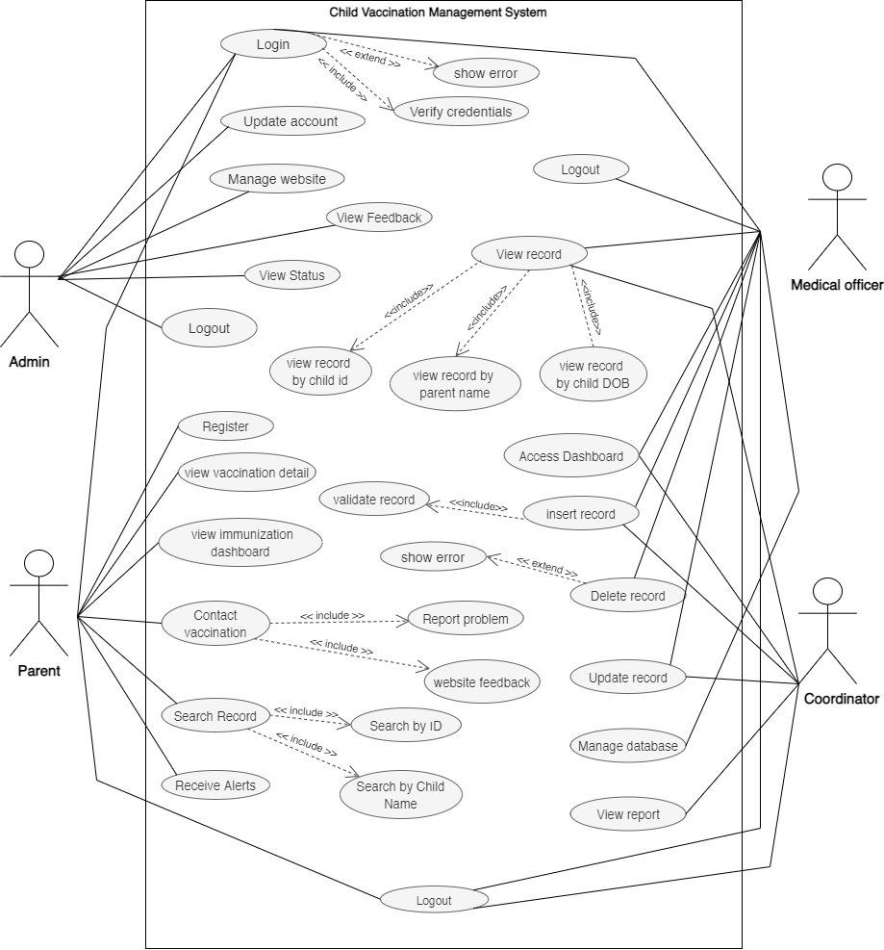

*Fig 3.4 Use Case Diagram of Child Vaccination Management System*

## Fully Dressed Use Cases

A carefully structured and detailed description enabling a deep understanding of the goals, tasks, and requirements. Details of all steps includes supporting sections such as preconditions and success guarantees.

|  |  |
| --- | --- |
| **UC-01** | **Login** |
| **Scope** | Online Child Vaccination System |
| **Primary Actor** | Parent, Admin, Coordinator, Medical Officer. |
| **Stakeholders and Interest** | The user wants to log-in to access the system and their accounts. |
| **Pre-Conditions** | 1: System must be in running state.  2: The user is not logging up from a non-existing account. |
| **Post Conditions** | The user logged in successfully and their dashboard is shown. |
| **Main Success Scenario** |  |
| **Actor** | **System** |
| 1. The user selects the “Log In “option.   2. The user enters the required credentials and submit. | 1: The system shows the log-in form to the student.  2: A successful message is shown after logged in. |
| **Alternate Scenario:** | 1: The system validates the entered information and displays the main screen else display the error message.  2:If the email or password is incorrect, the user would not be able to log in.  3: System may take a lot of loading time so its difficult to log in.  4: We might have an internet connection problem.  5: Database connectivity is also a big issue while performing this task.  6: Our server might be overwhelmed and we are unable to perform our task. |

**Table 3.5.1 Use Case for log in**

|  |  |
| --- | --- |
| **UC-02** | **View immunization dashboard** |
| **Scope** | Online Child Vaccination System |
| **Primary Actor** | Parent |
| **Stakeholders and Interest** | The user wants to view vaccination details on immunization dashboard. |
| **Pre-Conditions** | 1: the system must be in running state.  2:The user must be logged-in. |
| **Post Conditions** | User can successfully view vaccination details like vaccination date, vaccination status, child details, etc. |
| **Main Success Scenario** |  |
| **Actor** | **System** |
| 1: The user open the “Online Child Vaccination System” website in browser.  2: Then click on the option of “Immunization dashboard”. | 1: The system shows the details regarding vaccination.  2: It will also show stats of diseases with their rates in previous years. |
| **Alternate Scenario:** | 1: If the user failed to enter the system using log-in then they would be unable to access vaccination details.  2: Antivirus is blocking access to our website so we cannot view vaccination details.  3: Our browser may contain some corrupted files so we can no longer perform our task.  4: Our website theme may be incompatible which cause frequent problems. |

**Table 3.5.2 Use Case for Viewing Vaccination Details**

|  |  |
| --- | --- |
| **UC-03** | **View vaccination details** |
| **Scope** | Online Child Vaccination System |
| **Primary Actor** | Parent |
| **Stakeholders and Interest** | The user wants to view vaccination details of their child. |
| **Pre-Conditions** | 1: the system must be in running state.  2:The user must be logged-in. |
| **Post Conditions** | User can successfully view vaccination details along with their dosage and according to child’s age group. |
| **Main Success Scenario** |  |
| **Actor** | **System** |
| 1: The user open the “Online Child Vaccination System” website in browser.  2: Then user will select the “view vaccination details” option. | 1: Now system will allow users to view different vaccination along with their dosage and vaccine information. |
| **Alternate Scenario:** | 1: If the user failed to enter the system using log-in then they would be unable to manage their accounts.  2: We may have entered too much data in our database which is causing problems.  3: connectivity issues are major issues while performing this task.  4: Hardware acceleration can also cause hurdles. |

**Table 3.5.3 Use Case for Managing Accounts**

|  |  |
| --- | --- |
| **UC-04** | **Search Report** |
| **Scope** | Online Child Vaccination System |
| **Primary Actor** | Parent |
| **Stakeholders and Interest** | The user wants to search for their child’s vaccination details. |
| **Pre-Conditions** | 1: the system must be in running state.  2: The user must be logged-in.  3: User has to select the search option. |
| **Post Conditions** | User can successfully search their child's vaccination details. |
| **Main Success Scenario** |  |
| **Actor** | **System** |
| 1: Then user will select the “Search” option.  2: User can now search by either child name or child ID. | 1: System will show search results of child’s vaccination details. |
| **Alternate Scenario:** | 1: If System is not in running state or customer does not have internet so Searching would not be performed.  2: Hardware acceleration can also cause hurdles.  3: Domain name would get expired and we can no longer use our website or cannot perform this task.  4: Browsers incompatibility will be a reason for failure. |

**Table 3.5.4 Use Case for Searching details**

|  |  |
| --- | --- |
| **UC-05** | **Contact vaccination center** |
| **Scope** | Online Child Vaccination System |
| **Primary Actor** | Parent |
| **Stakeholders and Interest** | The user wants to contact the vaccination center to acquire additional information. |
| **Pre-Conditions** | 1: the system must be in running state.  2: User must ask their queries clearly. |
| **Post Conditions** | User have now successfully and quickly get their queries answered. |
| **Main Success Scenario** |  |
| **Actor** | **System** |
| 1: Then user will select the “Contact us” option.  2: User will now ask several queries related to vaccinations or dates or queries related to usage of system. | 1: Now system will provide them with quick and to the point answers related to each question. |
| **Alternate Scenario:** | 1: If question is abusive or is inappropriate then it is not entertained and user account may get blocked.  2:If the email or password is incorrect, the user would not be able to log in.  3: System may take a lot of loading time.  4: We might have an internet connection problem. |

**Table 3.5.5 Use Case for contacting vaccination center**

|  |  |
| --- | --- |
| **UC-06** | **Register** |
| **Scope** | Online Child Vaccination System |
| **Primary Actor** | Parent |
| **Stakeholders and Interest** | The user wants to book vaccination schedule. |
| **Pre-Conditions** | 1: the system must be in running state.  2: User must select available time slots and vaccinations. |
| **Post Conditions** | User has now booked vaccination schedule. |
| **Main Success Scenario** |  |
| **Actor** | **System** |
| 1: Then user will select the “Book Vaccination Schedule” option.  2: User will now enter details of child and select available time slots and dates. | 1: Now system will provide a confirmation message that user has successfully booked a schedule. |
| **Alternate Scenario:** | 1: If later on any issue appears then user would be informed and booking would be rescheduled.  2: Antivirus is blocking access to our website.  3: Our browser may contain some corrupted files so we can no longer perform our task.  4: Our website theme may be incompatible which cause frequent problems. |

**Table 3.5.6 Use Case for Booking Schedule**

|  |  |
| --- | --- |
| **UC-07** | **Report Problem** |
| **Scope** | Online Child Vaccination System |
| **Primary Actor** | Parent |
| **Stakeholders and Interest** | The user wants to report a problem about their child’s vaccination detail like the name of vaccination, date, or overall system performance. |
| **Pre-Conditions** | 1: the system must be in running state.  2:The user must be logged-in. |
| **Post Conditions** | User can successfully report a problem using system. |
| **Main Success Scenario** |  |
| **Actor** | **System** |
| 1: The user open the “Online Child Vaccination System” website in browser.  2: Then click on the option of “Report Problem”. | 1: The system would allow user to report problems regarding system delays like if user is unable to receive alerts on their mobile phones or email address. |
| **Alternate Scenario:** | 1: If the user failed to enter the system using log-in then they would be unable to report a problem or if the site is down due to maintenance then problem cannot be reported successfully.  2: We might have an internet connection problem.  3: Our server might be overwhelmed and we are unable to perform our task.  4:Site may be down. |

**Table 3.5.7 Use Case for Reporting a Problem**

|  |  |
| --- | --- |
| **UC-08** | **Receive Alerts** |
| **Scope** | Online Child Vaccination System |
| **Primary Actor** | Parent |
| **Stakeholders and Interest** | The user wants to receive timely vaccination alerts. |
| **Pre-Conditions** | 1: the system must be in running state.  2: The user must be logged-in and active on mobile to receive alert messages. |
| **Post Conditions** | User can successfully receive alert messages and can get notified through sms on their mobile phone about scheduled vaccination. |
| **Main Success Scenario** |  |
| **Actor** | **System** |
| 1: The user can use mobile phone to view vaccination alert messages. | 1: The system will send notification messages in offline mode to parents regarding the scheduled date of vaccination so that parents won’t miss the date. |
| **Alternate Scenario:** | 1: If the user won’t be able to check alerts or messages timely then the chance of getting their children’s vaccinated may be delayed.  2: slow internet connection can prevent us from receiving alerts.  3: connectivity issues are major issues while performing this task.  4: Hardware acceleration can also cause hurdles. |

**Table 3.5.8 Use Case for Receiving Vaccination Alerts**

|  |  |
| --- | --- |
| **UC-09** | **Access Dashboard** |
| **Scope** | Online Child Vaccination System |
| **Primary Actor** | Coordinator, Medical officer |
| **Stakeholders and Interest** | The Coordinator and Medical officer wants to access the dashboard. |
| **Pre-Conditions** | 1: the system must be in running state.  3:Coordinator must be logged-in. |
| **Post Conditions** | Coordinator or Medical officer has viewed the entire dashboard which has information related different vaccines and disease rates in different areas. |
| **Main Success Scenario** |  |
| **Actor** | **System** |
| 1: Then Coordinator will select the “Access Dashboard” option. | 1: Now system will display a dashboard which show information related different vaccines and disease rates in different areas. |
| **Alternate Scenario:** | 1: If medical officer or coordinator fail to login in the system then he would be unable to access the dashboard.  2: System may take a lot of loading time.  3: We might have an internet connection problem.  4: Database connectivity is also a big issue while accessing dashboard successfully. |

**Table 3.5.9 Use Case for Access Dashboard**

|  |  |
| --- | --- |
| **UC-10** | **View Report** |
| **Scope** | Online Child Vaccination System |
| **Primary Actor** | Coordinator |
| **Stakeholders and Interest** | The Coordinator wants to view vaccination report. |
| **Pre-Conditions** | 1: the system must be in running state.  2: Coordinator must be logged-in and verified so that he can view reports easily. |
| **Post Conditions** | Coordinator has now viewed vaccination reports of different children’s. |
| **Main Success Scenario** |  |
| **Actor** | **System** |
| 1: Then Coordinator will select the “View Report” option. | 1: Now system will show different reports to Coordinator and he will be able view all reports of vaccination from different perspective like date wise, Month wise or on specific date. |
| **Alternate Scenario:** | 1: If coordinator fails to log-in in the system then he would be unable to view reports.  2: Hardware acceleration can also cause hurdles for viewing report.  3: Domain name would get expired and we can no longer use our website or cannot perform this task.  4: Browsers incompatibility will be a reason for failure. |

**Table 3.5.10 Use Case for Viewing Report**

|  |  |
| --- | --- |
| **UC-11** | **Insert, Update, Delete Record** |
| **Scope** | Online Child Vaccination System |
| **Primary Actor** | Medical Officer |
| **Stakeholders and Interest** | The Medical Officer wants to be able to insert, update and delete data in the application if they want and Coordinator can only insert and update data in records. |
| **Pre-Conditions** | 1: the system must be in running state.  2: Medical Officer must be logged-in to access data. |
| **Post Conditions** | Medical Officer has now inserted, updated or deleted user records. |
| **Main Success Scenario** |  |
| **Actor** | **System** |
| 1: Then Medical Officer will select the “Manage Data” option. | 1: Now system will show different records to Medical Officer to modify them if necessary. |
| **Alternate Scenario:** | 1: Medical officer would not be able to insert data or update data in a particular record at a time both task cannot be performed simultaneously.  2: System may take a lot of loading time.  3: We might have an internet connection problem.  4: Database connectivity is also a big issue while performing this task. |

**Table 3.5.11 Use Case for Managing data**

|  |  |
| --- | --- |
| **UC-12** | **Manage Database** |
| **Scope** | Online Child Vaccination System |
| **Primary Actor** | Medical Officer |
| **Stakeholders and Interest** | The Medical Officer wants to manage database of child vaccination system. |
| **Pre-Conditions** | 1: the system must be in running state.  2: Medical Officer must be logged-in to access database. |
| **Post Conditions** | Medical Officer has now inserted, updated or deleted user data in database. Medical Officer can also create or remove users from the system. |
| **Main Success Scenario** |  |
| **Actor** | **System** |
| 1: Then Medical Officer will select the “Manage Database” option. | 1: Now system will give access of database to Medical Officer and he will now perform his desired operations in that database. He can either apply a query or create or remove users in tables. |
| **Alternate Scenario:** | 1: If permission is not granted to Medical officer then he would not be able to make changes to database.  2: Our browser may contain some corrupted files so we can no longer manage our database.  3: Our website theme may be incompatible which cause frequent problems. |

**Table 3.5.12 Use Case for Managing Database**

|  |  |
| --- | --- |
| **UC-13** | **View Record** |
| **Scope** | Online Child Vaccination System |
| **Primary Actor** | Medical officer, Coordinator |
| **Stakeholders and Interest** | The Coordinator and Medical officer wants to view child’s record. |
| **Pre-Conditions** | 1: the system must be in running state.  2: Coordinator and Medical officer must be logged-in and verified so that he can view reports easily. |
| **Post Conditions** | Medical officer has now viewed child’s medical record. |
| **Main Success Scenario** |  |
| **Actor** | **System** |
| 1: Then Coordinator will select the “View Child’s Record” option. | 1: Now system will show different record to Coordinator or Medical officer and they will be able view all records or record of a specific child. |
| **Alternate Scenario:** | 1: If coordinator fails to log-in in the system then he would be unable to view reports.  2: Their may be a problem in database from where records have been retrieved.  3: We might have an internet connection problem so we can not view records.  4: Database connectivity is also a big issue while performing this task.  5: Our server might be overwhelmed and we are unable to perform our task. |

**Table 3.5.13 Use Case for Viewing Records**

|  |  |
| --- | --- |
| **UC-14** | **Manage Website** |
| **Scope** | Online Child Vaccination System |
| **Primary Actor** | Admin |
| **Stakeholders and Interest** | The Admin wants to manage the website of Child Vaccination System. |
| **Pre-Conditions** | 1: the system must be in running state.  2: Admin must be logged-in with right credentials to manage website. |
| **Post Conditions** | Admin has now managed the website like he can update contact information and upload new stuff which would be useful for other users. |
| **Main Success Scenario** |  |
| **Actor** | **System** |
| 1: Then Admin will select the option of “Manage Website”. | 1: After log-in now system will allow Admin to manage the complete website, he can make changes to different modules of website which he has access to and Admin can update the website timely. |
| **Alternate Scenario:** | 1: If permission is not granted to Admin for entering wrong credentials then website would not be managed by Admin.  2: We may have entered too much data in our database which is causing problems for managing our website.  3: connectivity issues are major issues while performing this task.  4: Hardware acceleration can also cause hurdles. |

**Table 3.5.14 Use Case for Managing Website**

|  |  |
| --- | --- |
| **UC-15** | **View Vaccination status** |
| **Scope** | Online Child Vaccination System |
| **Primary Actor** | Admin |
| **Stakeholders and Interest** | The Admin wants to view vaccination status of different children’s. |
| **Pre-Conditions** | 1: the system must be in running state.  2: Admin must be logged-in with right credentials to view vaccination status. |
| **Post Conditions** | Admin has now viewed different children’s vaccination status that either it is completed or Scheduled. |
| **Main Success Scenario** |  |
| **Actor** | **System** |
| 1: Then Admin will select the option of “Viewing Vaccination Status”. | 1: After login now system will allow Admin to view vaccination status and then help users in booking schedules. |
| **Alternate Scenario:** | 1: If permission is not granted to Admin for entering wrong credentials then he would not view status.  2: Hardware acceleration can also cause hurdles.  3: Browsers incompatibility will be a reason for we can not view our vaccination status. |

**Table 3.5.15 Use Case for Viewing Vaccination Status**

|  |  |
| --- | --- |
| **UC-16** | **Manage feedback** |
| **Scope** | Online Child Vaccination System |
| **Primary Actor** | Admin |
| **Stakeholders and Interest** | The Admin wants to view and manage feedback of users. |
| **Pre-Conditions** | 1: the system must be in running state.  2: Admin must be logged-in with right credentials to view feedback. |
| **Post Conditions** | Admin has now viewed different users’ feedback regarding the usage and services of system. |
| **Main Success Scenario** |  |
| **Actor** | **System** |
| 1: Then Admin will select the option of “Handling Feedback”. | 1: After login now system will allow Admin to view and handle users’ feedback and reply to them. |
| **Alternate Scenario:** | 1: If abusive language is used in feedback then Admin would not be able to reply users.  2: Antivirus is blocking access to our website.  3: Our browser may contain some corrupted files so we can no longer manage our feedback.  4: Our website theme may be incompatible which cause frequent problems. |

**Table 3.5.16 Use Case for Handling Feedback**

**CHAPTER 4**

**System Design**

# System Design

## 4.1.1 Class Diagram

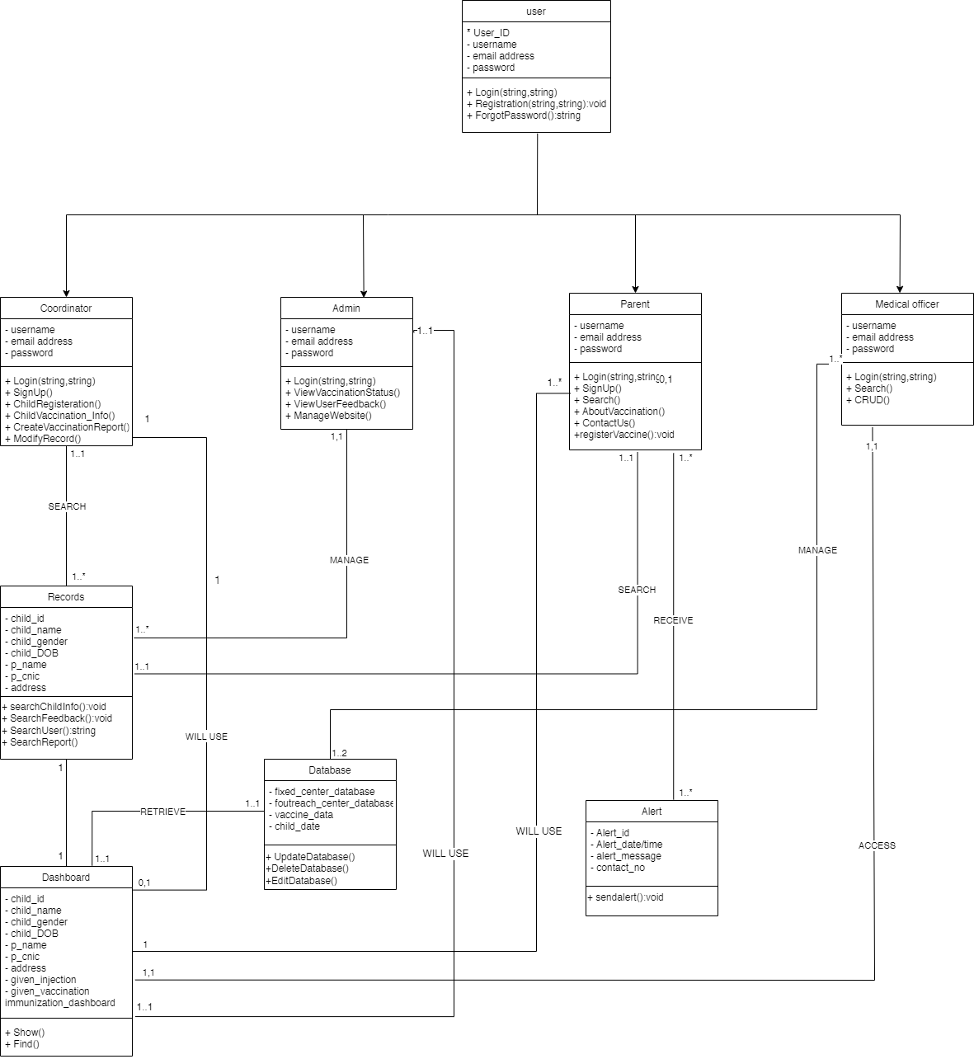

*Fig 4.1.1 Class Diagram of Child Vaccination Management System*

## 4.2 Interaction Diagram (Sequence):

### 4.2.1 Sequence Diagram of Login:

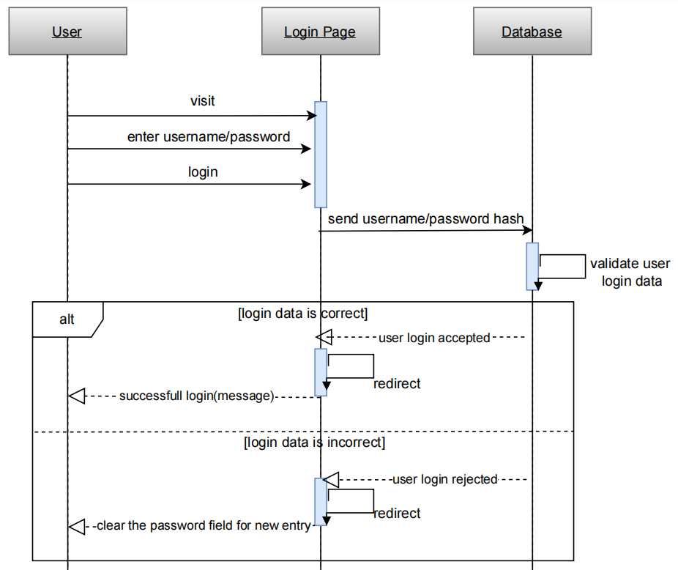

*Fig 4.2.1 Sequence Diagram of Login*

### 4.2.2 Sequence Diagram of Register:

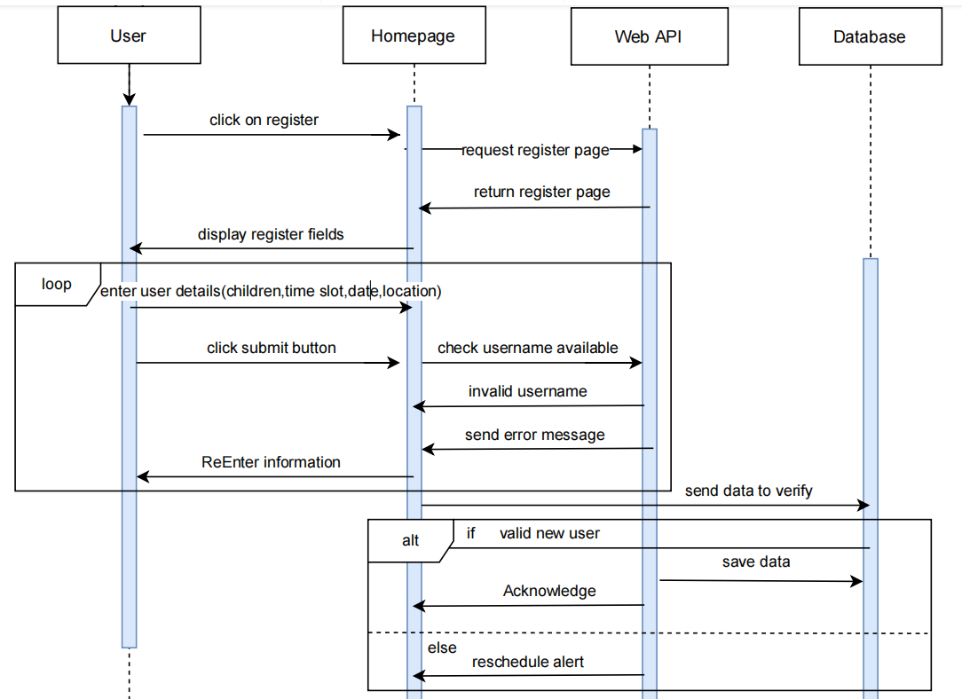

*Fig 4.2.2. Sequence Diagram of Register*

### 4.2.3 Sequence Diagram of View and manage Feedback:

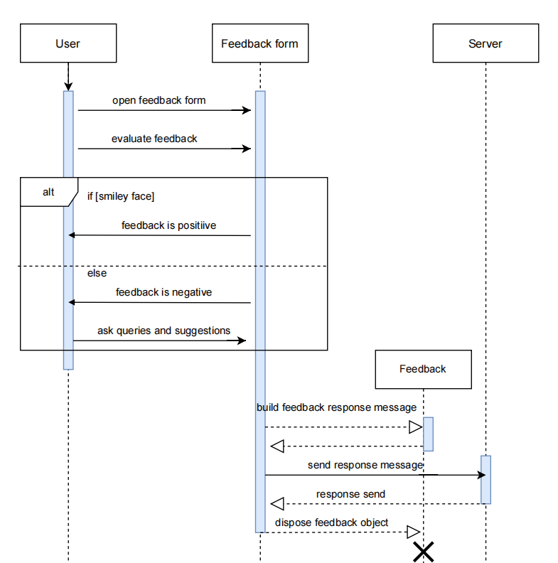

*Fig 4.2.3. Sequence Diagram of View and Manage Feedback*

### 4.2.4 Sequence Diagram of View Report:

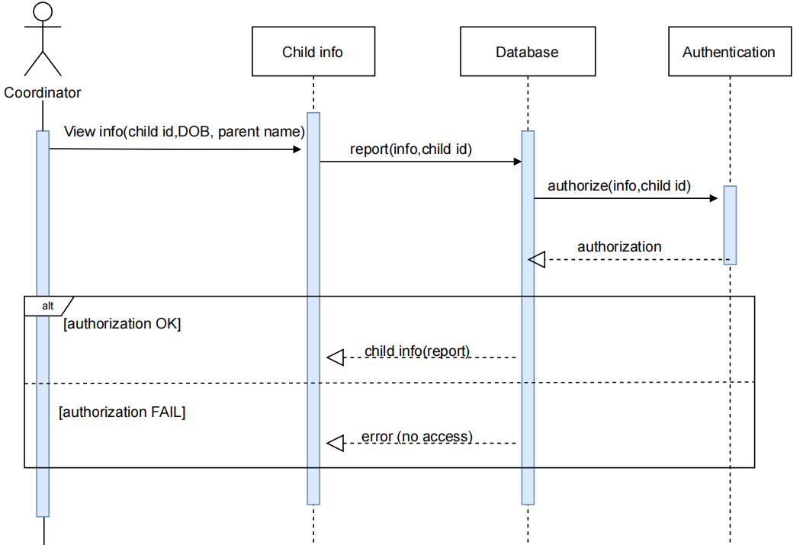

*Fig 4.2.4. Sequence Diagram of View Report*

### 4.2.5 Sequence Diagram of Access Dashboard:

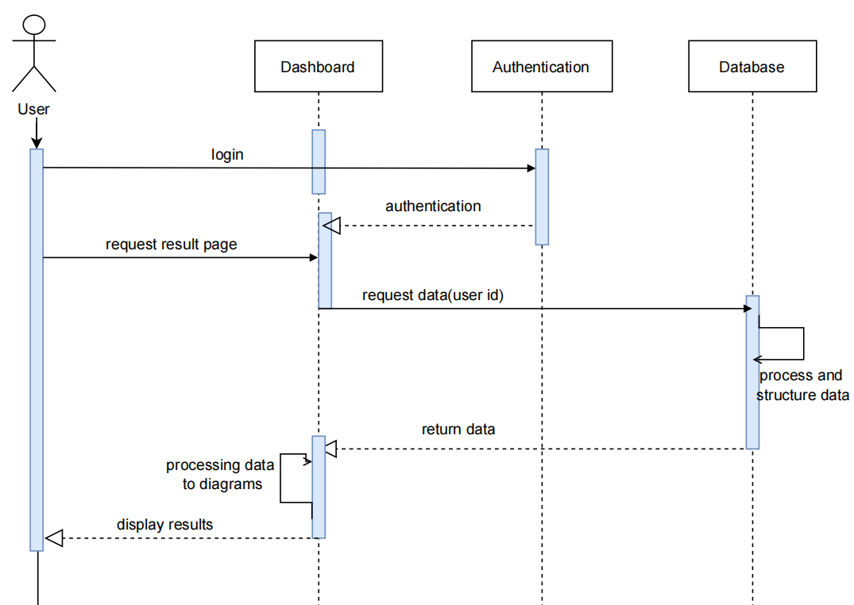

*Fig 4.2.5. Sequence Diagram of Access Dashboard*

## 4.3 Entity Relation Diagram:

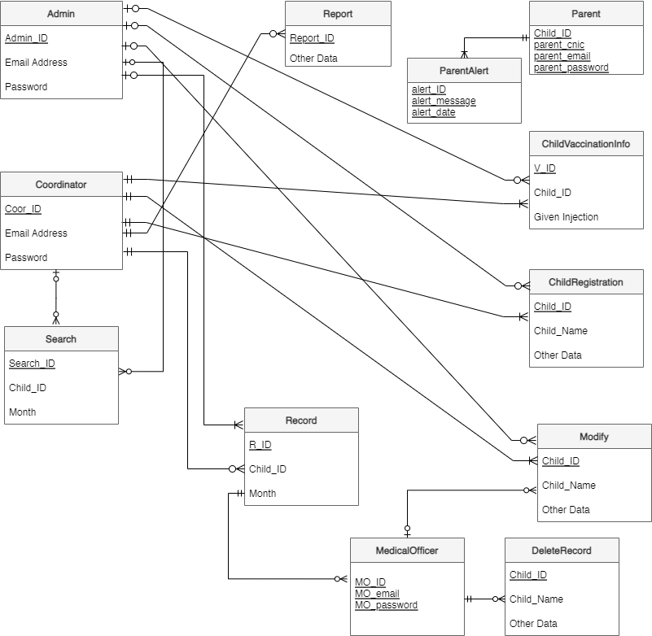

*Fig 4.3. Entity Relation Diagram of Child Vaccination Management System*

## 4.4 Activity Diagram:

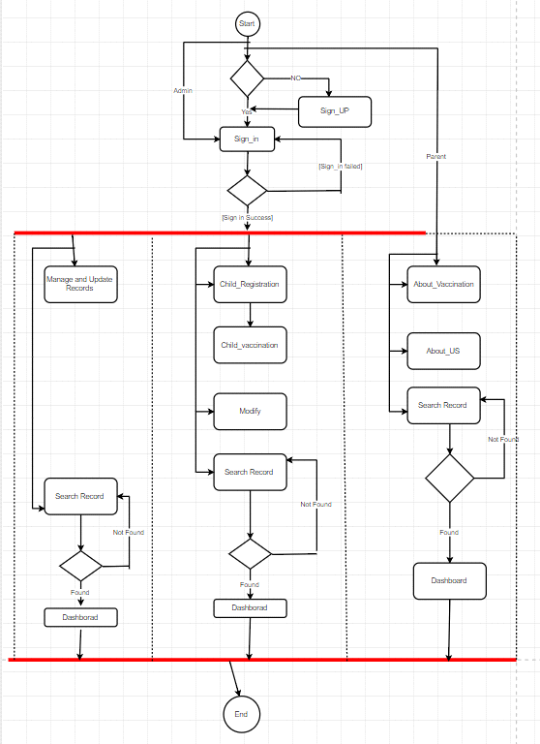

*Fig 4.4 Activity Diagram of Child Vaccination Management System*